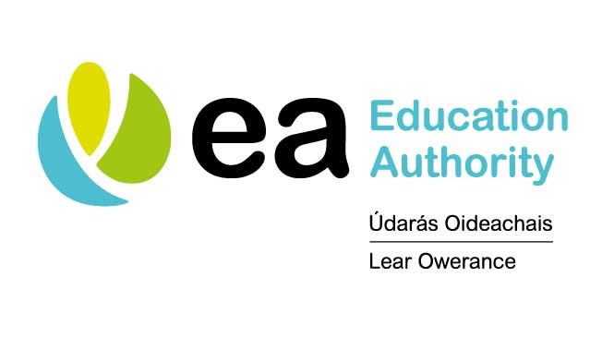

Dear Mr Bradley 2 April 2020

**Re Support for schools during the COVID 19 situation: Designated Link Officer**

Thank you most sincerely for your good will and for the crucial work you and your colleagues are doing to help key workers and vulnerable children at this time of crisis.

Thank you, too, for the immense investment you and your colleagues have made into planning for and supporting continued learning for the children and young people of your school community. Your flexibility, innovation and generosity in sharing expertise is greatly appreciated by EA and by our partner organisations. We want to ensure that, in your vital role as a school leader, in this crisis situation, you:

* remain directly connected to the wider educational community;
* receive accurate information from a trusted source, which is consistent across all our settings;
* have one clear, continuous and reliable point of contact through which you can have your individual issues resolved promptly;
* are supported in making provision for continuity of learning and/or a supervised learning environment for pupils;
* are able to communicate your experiences to a central point, so that they inform and help all of us in to support schools and pupils, in the weeks and months ahead;
* have a trusted peer if you simply want to sound something out.

To this end, we are working collaboratively with our colleagues in CCMS, CSSC and ETI and have assigned a Link Officer from one of our organisations to your school.

Your Link Officer is Miriam Coffey from the Education Authority.

She can be reached at 07826932180 or [miriam.coffey@eani.org.uk](mailto:miriam.coffey@eani.org.uk)

***Please forward your work mobile number to your designated officer by return.***

Your Officer, if she has not already done so, will make contact with you in the very near future.

Thank you again for your important contribution and for your patience as we work together to bring our communities safely through these uncertain times.

Yours truly,

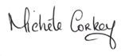

**On behalf of all of our partner organisations**

**Michele Corkey**

**Director of Education**