All Saints’ Primary School
42 Tattysallagh Road,
Omagh, Co. Tyrone.
BT78 5BR
(028) 82243233
Email: abradley561@c2kni.net
7th April 2020

Dear Parent/Carer,

As we enter Holy Week, I just wanted to get in touch with you to reassure you that…

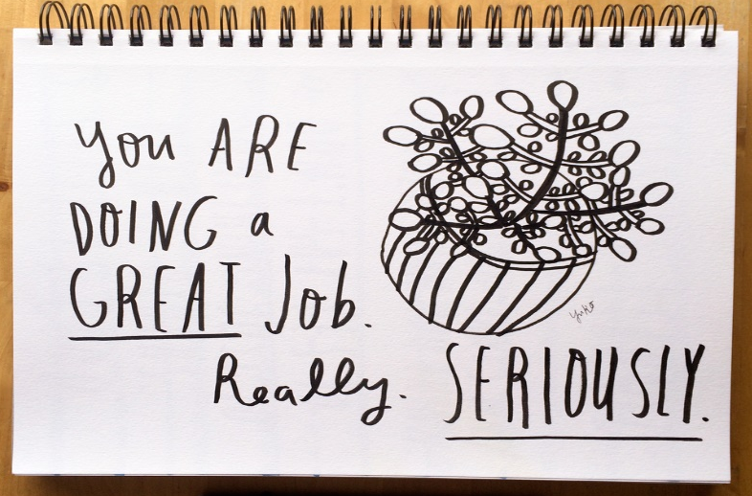

A big ‘thank you’ to all our teachers, assistants and Marie and Fiona in the office for preparing and distributing the work packs a few weeks ago. Thanks also to Charlie, Christina and Mary in the kitchen for their excellent cleaning work in preparation for our re-entering the school to allow us to do so. Thanks also to yourselves for the very orderly collection of the work packs.

WORK PACKS

Many of you will be, quite rightly, feeling worried and anxious with everything that is happening at present and for many of you, the work we sent home for children following our closure may feel like an added pressure. It’s not meant to be, but you now find yourselves in the role of the ‘teacher’, a position that may be unfamiliar to many no doubt.

Many of you may now be working from home. This is challenging enough without the added pressure of trying to teach your child. Much of the work provided in our packs should allow your child to work independently and we hope that this will let you to focus upon important elements of your own work that may need attended to.

The pupil work packs should provide ample work up to, and possibly beyond, the Easter Holidays. At Easter, give your child and yourself a break from learning packs etc. After Easter, our staff will continue to provide ‘remote learning’ via our school website and will keep you informed about further work packs as necessary.

WHAT YOU NEED TO DO

…do the best that you can! The pupil work packs sent home a few weeks ago should provide enough activities to keep your child learning. Children are not expected to complete every single activity and there will be days when your child is eager to complete tasks and other days when they will not. That’s not a problem…it’s not a ‘must-do’. Children are far more resilient than we give them credit for and they will no doubt bounce back when ‘normal’ schooling returns.

WHAT YOU CAN DO?

If at all possible, ensure that your child reads or is read to each day. Older pupils can continue to use Accelerated Reader and Mathletics form the website along with many other activities that the teachers have added. Where appropriate, continue phonic work, learning tables, reading time, money, measuring, problem solving, counting and exploring language such as taller, shorter, most, least, etc.

CHILDREN... get plenty of exercise, play games outside and inside, read, listen to stories, complete puzzles, cook and bake together, help at home to prepare snacks and lunches and even watch a bit of TV or a movie (not too much though!). Please also remember to say your daily prayers and say a special prayer for all of those people who are helping us every day.

Try to include physical activity every day, build with LEGO if you have it or recycle junk materials to create a sculpture. Sort toys, paint if possible, cut and stick. Use your imagination or find endless activities on-line.

Please, please, please… do not feel any that you have to do everything, or anything, that’s been mentioned. These are only ideas and suggestions and you will know what suits your child and circumstances best. Your children may be worried and their minds will be filled with questions. They will miss their friends and perhaps even some will miss the routine of school life. Your encouragement, positivity, support, time and of course your love, will help them more than anything to navigate these difficult times.

In conclusion, I’ll leave you with the words of The Holy Father, who put it much better than I ever could, when he said…

"Today too, amid so much darkness, we need to see the light of hope and to be men and women who bring hope to others. To protect creation, to protect every man and every woman, to look upon them with tenderness and love, is to open up a horizon of hope; it is to let a shaft of light break through the heavy clouds; it is to bring the warmth of hope!"

Pope Francis

That’s his challenge for all adults.
It’s also the challenge for all parents and carers in these very difficult times.

Please keep safe, take care and remember “…you’re doing a great job!”

Kind regards,

Anthony Bradley

Acting Principal.

