9 April 2020

**To all Principals**

**To all Principals of Catholic Maintained Schools**

Easter is a time of celebration, hope and joy. It is a time when we are reaffirmed in the centrality of the Easter story in our lives as People of the Resurrection. It is a time when darkness gives way to light. The Cross becomes a sign, not of defeat but of Victory.

Despite the joy of the Resurrection that fills our hearts, this Easter speaks to a global reality of uncertainty, fear and panic, with the challenges of the indiscriminate Covid-19 pandemic. Some of your communities will have already suffered through illness and even death. And yet, at a time of so much distress and perplexity, the Cross of Victory leads us with confidence to trust that we will overcome this crisis and the challenges that it brings, and that we can all eventually re-build a sense of normality – in our homes, in our school families, in our parish communities and in our bigger world.

We write at this time to commend you as school principals for the inspired leadership and courage that you continue to demonstrate in the midst of this extremely challenging and worrying time. Your ongoing resilience and resolve to work together for the common good is laudable. Your support and the services you are providing for your pupils and their families - not only within your own schools, but across the wider education community - has been most reassuring and welcoming. In a time of fear and loneliness, the strength of your communities is a precious gift.

On behalf of CCMS, we wish to thank you for your calm, joined-up leadership and support that you continue to give to our educational partners, our pupils, their families and other stakeholders throughout this period. There is a collective strength as we all travel this journey together. I ask you to pass on sincere thanks to your school staff, your families and all who support you at this time in your endeavours.

We will continue to hold in our prayers all who are working to overcome this crisis, whether they be in education or other front-line services such as the Health and Social Care sector.

Yours sincerely

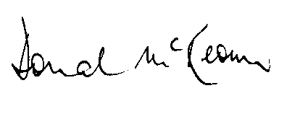

**Bishop Donal McKeown DD Gerry Campbell**

**CHAIR CHIEF EXECUTIVE**