Month | Day | Date | Reason
October 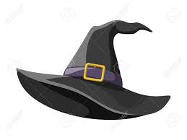 | Monday | 2nd  30th/31st | Staff development  Halloween
December | Friday  Thursday | 1st  21st | Staff development  School closes 12.00 noon for the Christmas Break. Children return on Monday 8th January 2024
February | Mon - Friday | 12th – 16th | Mid Term Break
March | Friday  Monday  Friday | 15th  18th  29th | St. Patrick’s Day break  Staff Development  Good Friday. School closes at 12 noon on Thursday 28th
April | Monday - Friday | 1st –  5th | Easter holidays  Children return to school on Monday 8th April.
May | Monday  Tuesday  Monday  Tuesday | 6th –  7th  27th  28th | May Bank Holiday  Spring Bank Holiday  Staff only
June | Friday | 28th | School closes at 12.00 noon for the summer break

Holidays are subject to change. We will keep you informed if this happens.
.

